JAVA FSE ASSIGNMENT:

WEEK 03: Spring_core

Exercise 1 :

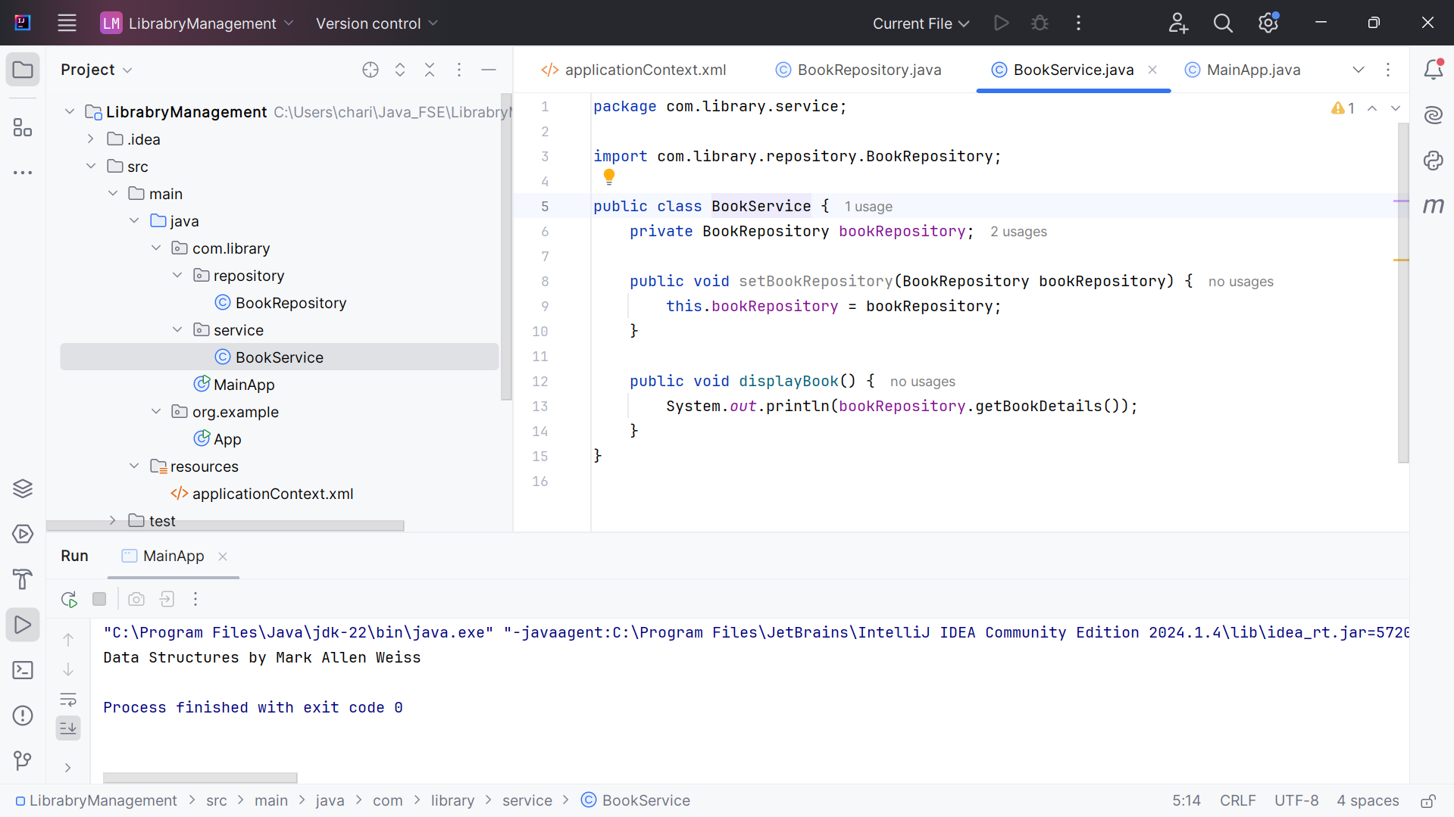

Exercise 2:

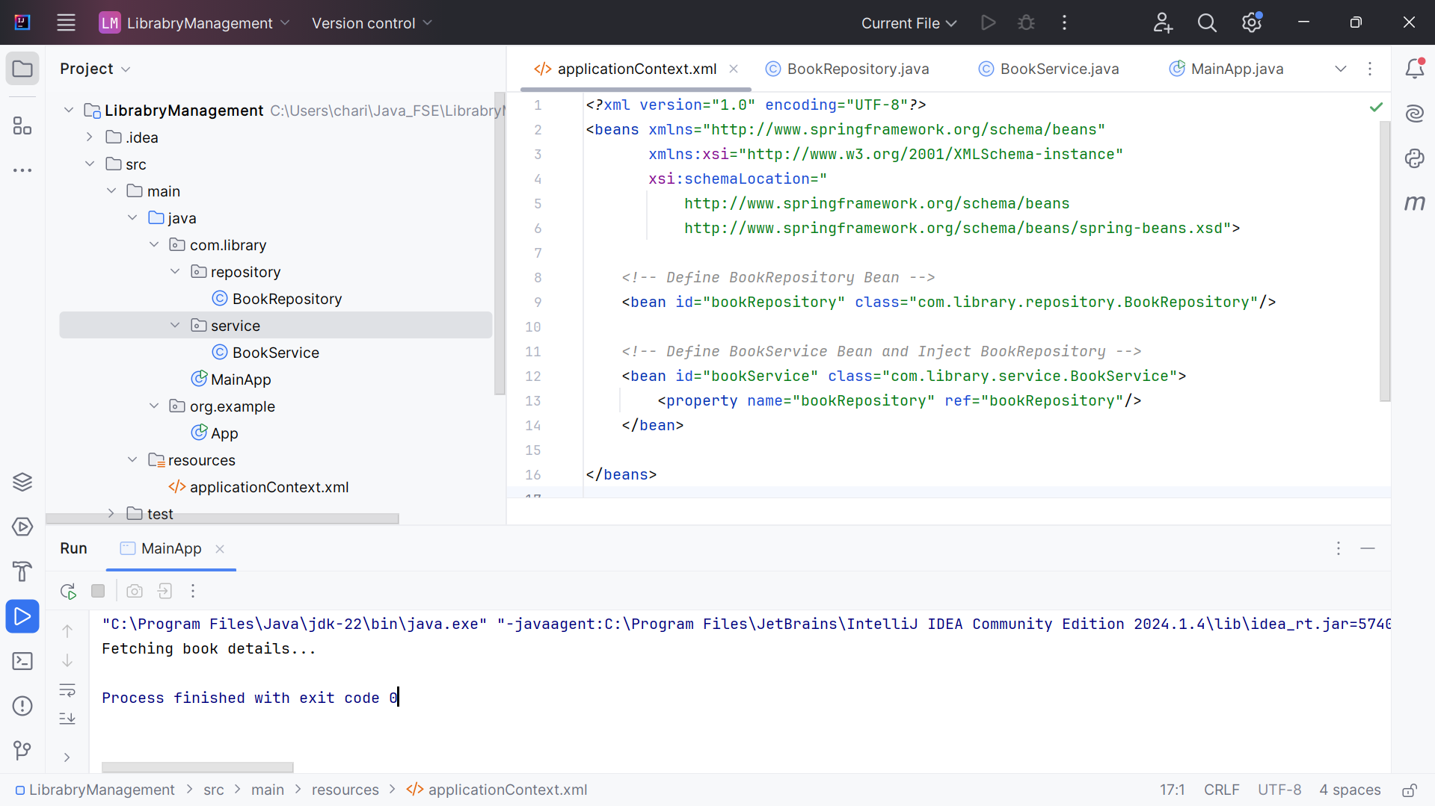

Exercise 4:

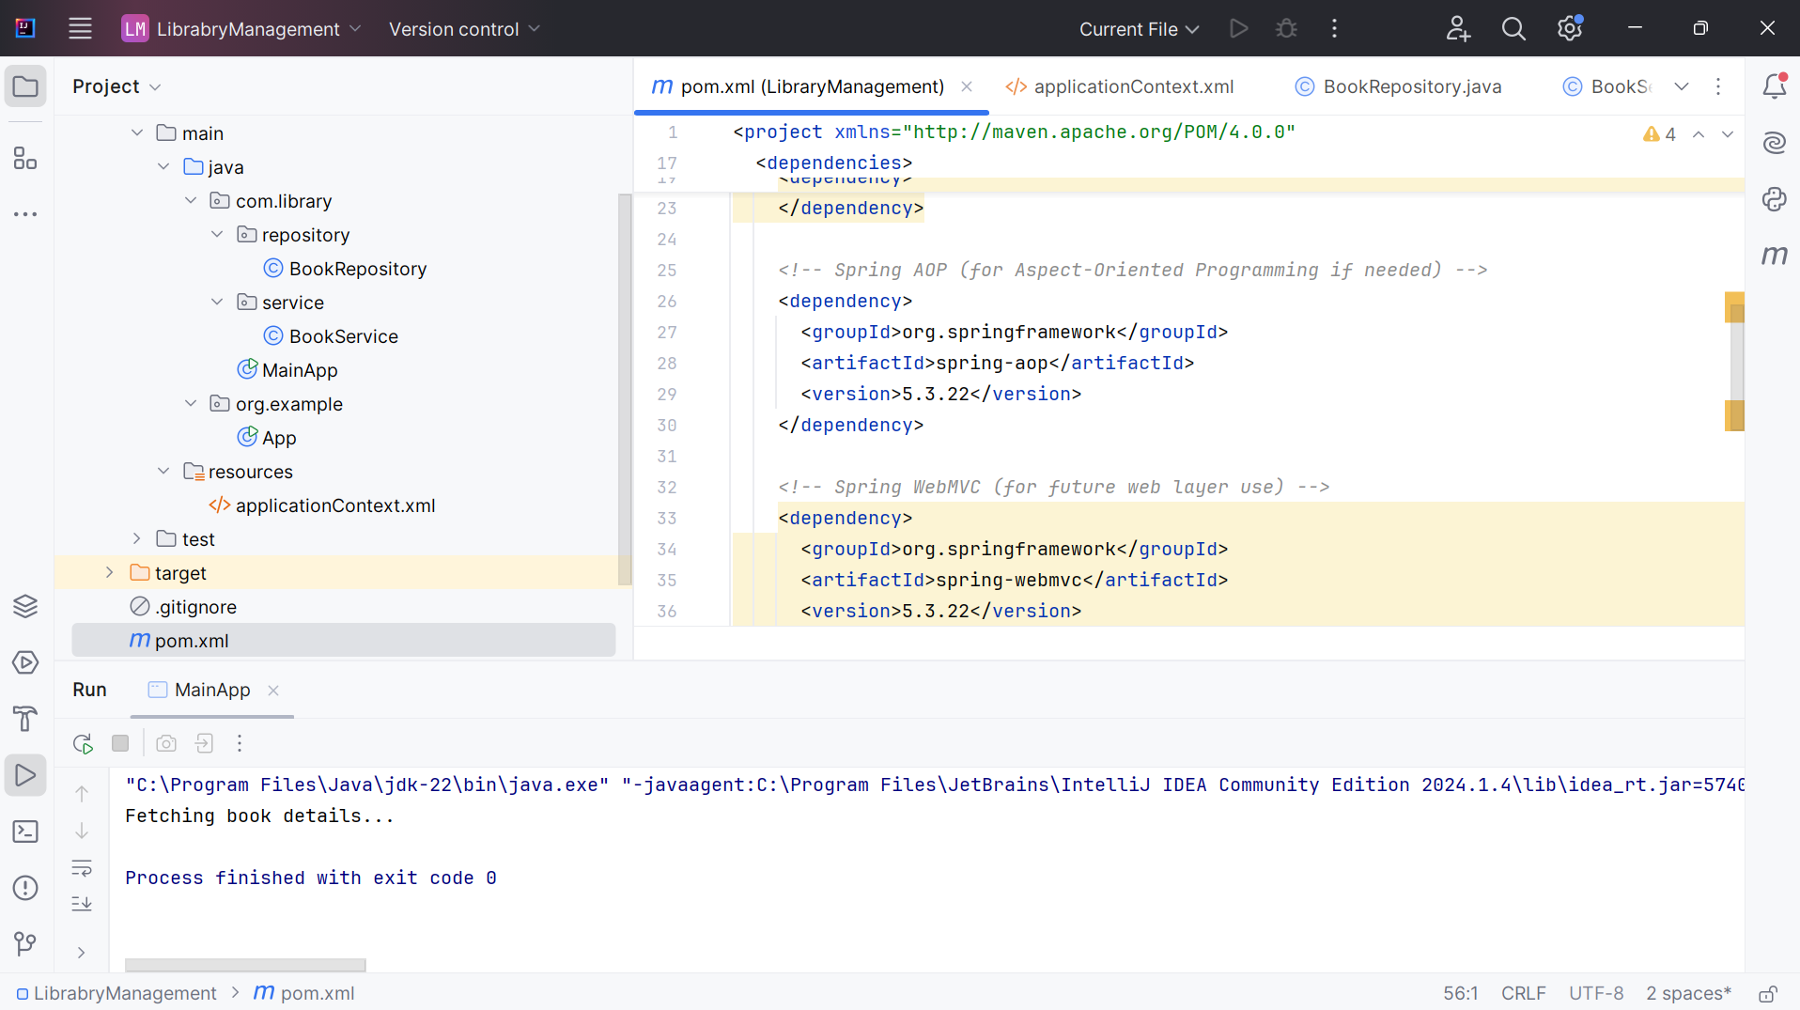

Other hands-on have been done and verified using the zip from [Spring Initializr](https://start.spring.io/).